Febrile Infant Guideline: Previously Healthy, Full-Term 0 to 60 days of age
Adapted from AAP Clinical Practice Guideline: Evaluation and Management of Well-Appearing Febrile Infants 8 to 60 Days Old. Pediatrics. August 2021.148(2). 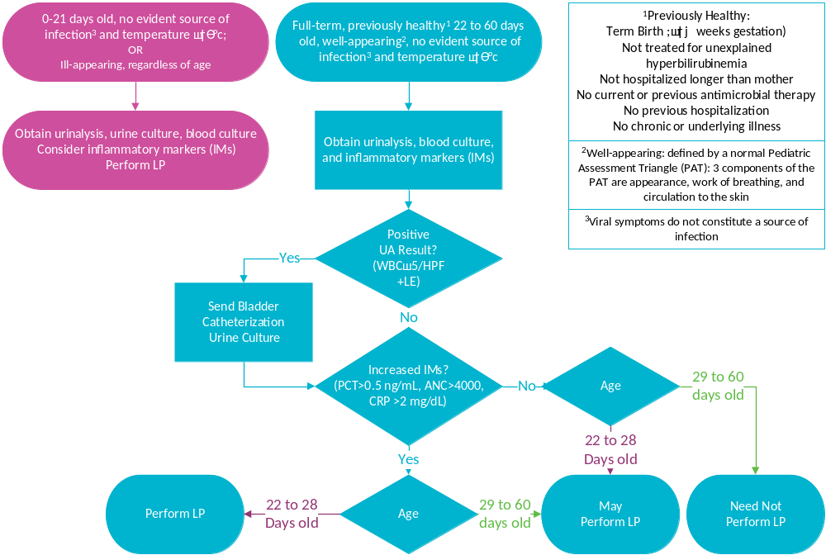
Definitions
Fever | Temperature > 38ºC (100.4 ºF) at home or in the clinical setting
Invasive bacterial infection (IBI) | Bacteremia and/or bacterial meningitis in infants ≤ 60 days of age
Serious bacterial infection (SBI) | A urinary tract infection, bacterial meningitis, bacteremia, bacterial pneumonia, gastroenteritis, cellulitis, osteomyelitis, or septic arthritis

